The Kendrick Brothers, Kirk Cameron Entertainment and Fathom Events Announce Release of the Inspirational Adoption Film, LIFEMARK

New Film - Based on a True Story - Featuring Kirk Cameron and Alex Kendrick

Fathom Events To Give This Highly-Anticipated Faith-Based Film a First-Time National Premiere Run of 7 Days Starting on September 9th
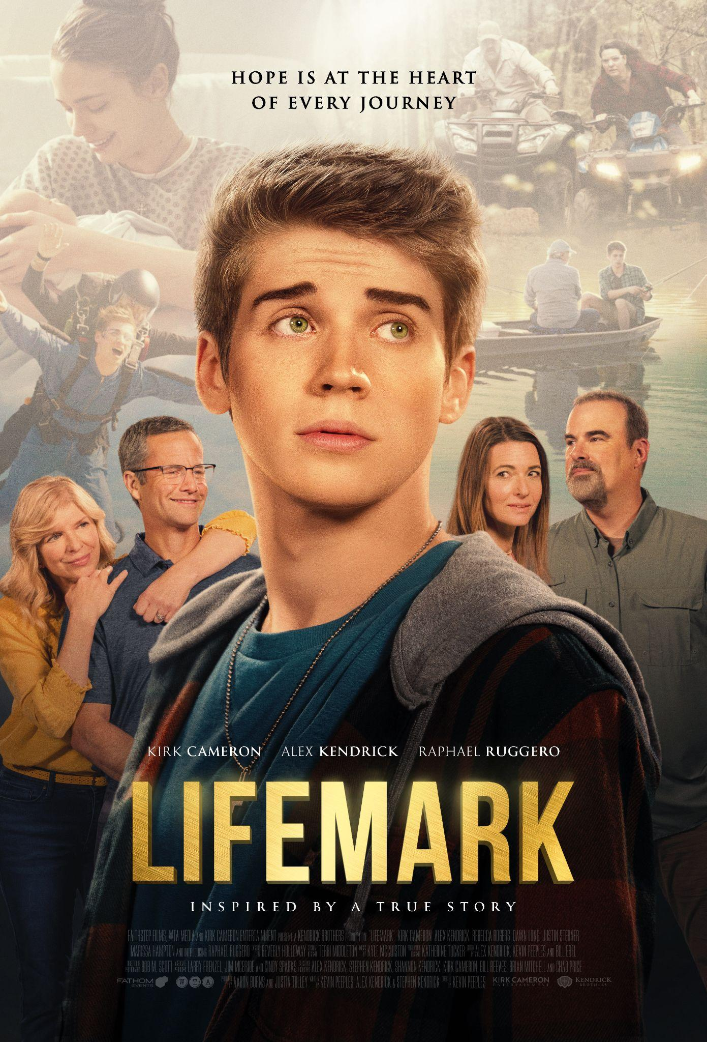
NASHVILLE, Tenn. (June 7, 2022) — The Kendrick Brothers, Kirk Cameron Entertainment and Fathom Events announce the release of their latest film LIFEMARK, premiering in theaters nationwide on September 9th. Based on the documentary ‘I Lived On Parker Avenue,’ LIFEMARK is the true story of a young man’s journey as he sets out to meet his birth parents. With a talented cast, including Kirk Cameron (“Growing Pains,” FIREPROOF), Alex Kendrick (COURAGEOUS, OVERCOMER), Rebecca Rogers (WALKING IN SOUTHPORT, TEXAS REIN), Dawn Long (TREASURE LIES, COWBOYS), Raphael Ruggero (THE ASSIGNMENT), Justin Sterner (“American Detective, KID COMBAT) and Marisa Hampton (THE RELIANT, “Dynasty”), LIFEMARK is a reminder that one courageous decision can change everything.

The film will be released in movie theaters nationwide September 9, 2022 for a seven-day run. Tickets are available here.

Watch the Featurette of LIFEMARK here.

“We believe LIFEMARK will inspire countless people and churches at this pivotal time to get more involved in supporting life and adoption. This movie has something for everyone. It’s inspirational, entertaining, and also life changing.” said Executive Producer Stephen Kendrick.

David’s comfortable world is turned upside down when his birth mother unexpectedly reaches out to him, longing to meet the 18-year-old son she’s only held once. With the encouragement of his adoptive parents, David embarks on a journey of discovery that leads to a staggering truth from his past. From executive producers Kirk Cameron and the Kendrick Brothers—creators of WAR ROOM and FIREPROOF—comes LIFEMARK, based on an incredible true story that celebrates adoption, reconciliation, and love.

“It is a joy to be able to bring this real-life story to the big screen,” said Actor and Executive Producer Alex Kendrick. “We are thrilled to partner with Fathom Events for the first time and believe that this film will bring hope to many people.”

“The team at Fathom Events is very excited to partner with the Kendrick Brothers and Kirk Cameron on LIFEMARK,” said Ray Nutt, CEO of Fathom Events. “We believe in this film so much that we are going to premiere it in theaters nationwide for a seven-day limited engagement so that audiences have more opportunities to see the film.”

For more information, visit https://www.fathomevents.com/events/LIFEMARK or http://lifemarkmovie.com and follow on social media at @lifemarkmovie.

Get all the latest news from The Kendrick Brothers at kendrickbrothers.com and follow them on Facebook at @kendrickbrothers and Twitter at @KendrickBros.
About Fathom Events
Fathom is a recognized leader in the entertainment industry as one of the top distributors of content to movie theaters in North America. Owned by AMC Entertainment Inc. (NYSE: AMC); Cinemark Holdings, Inc. (NYSE: CNK); and Regal, a subsidiary of the Cineworld Group (LSE: CINE.L), Fathom operates the largest cinema distribution network, delivering a wide variety of programming and experiences to cinema audiences in all the top U.S. markets and to more than 45 countries. For more information, visit www.FathomEvents.com.

About Kendrick Brothers Productions
Kendrick Brothers Productions is the company of brothers Alex, Stephen and Shannon Kendrick that exists to honor God and share the truth and love of Jesus Christ through movies, books, curriculum and speaking. By blending engaging stories with doctrinal integrity, the Kendricks seek to encourage and inspire audiences with resources that positively impact their lives and strengthen their faith, families, and personal relationships.

Kirk Cameron Entertainment:
Kirk Cameron Entertainment exists to create high quality, inspirational films featuring the faith and family building virtues of Truth, Beauty and Goodness for audiences of all ages.

###

Media Contacts:
Nicole Crumbley | EPIC
nicole@epic.inc
770-286-1144

Colette Carey | Fathom Events
ccarey@fathomevents.com
(720) 815-6800

